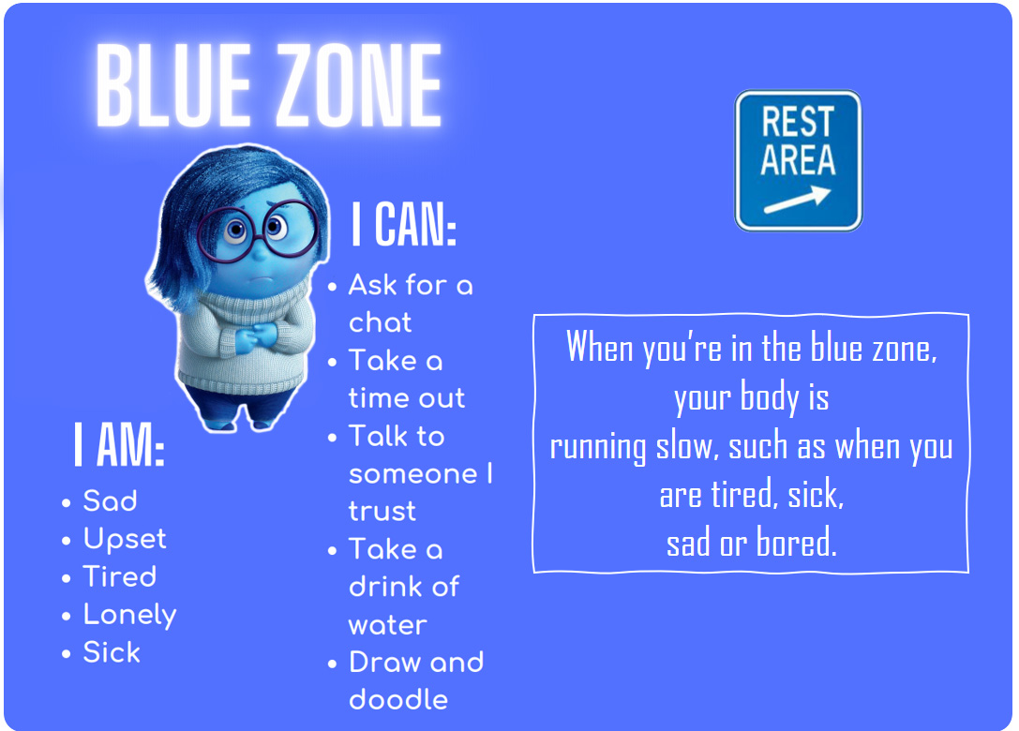
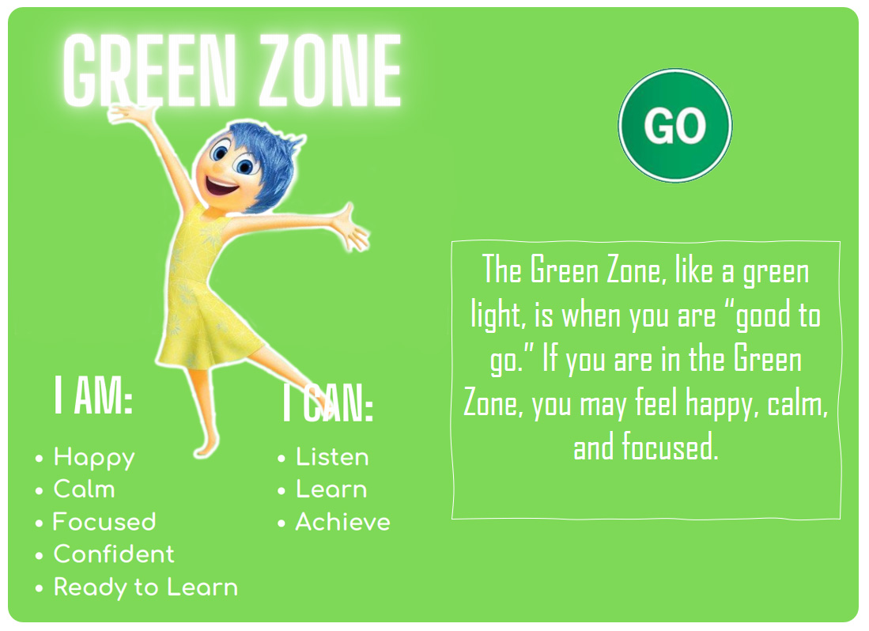
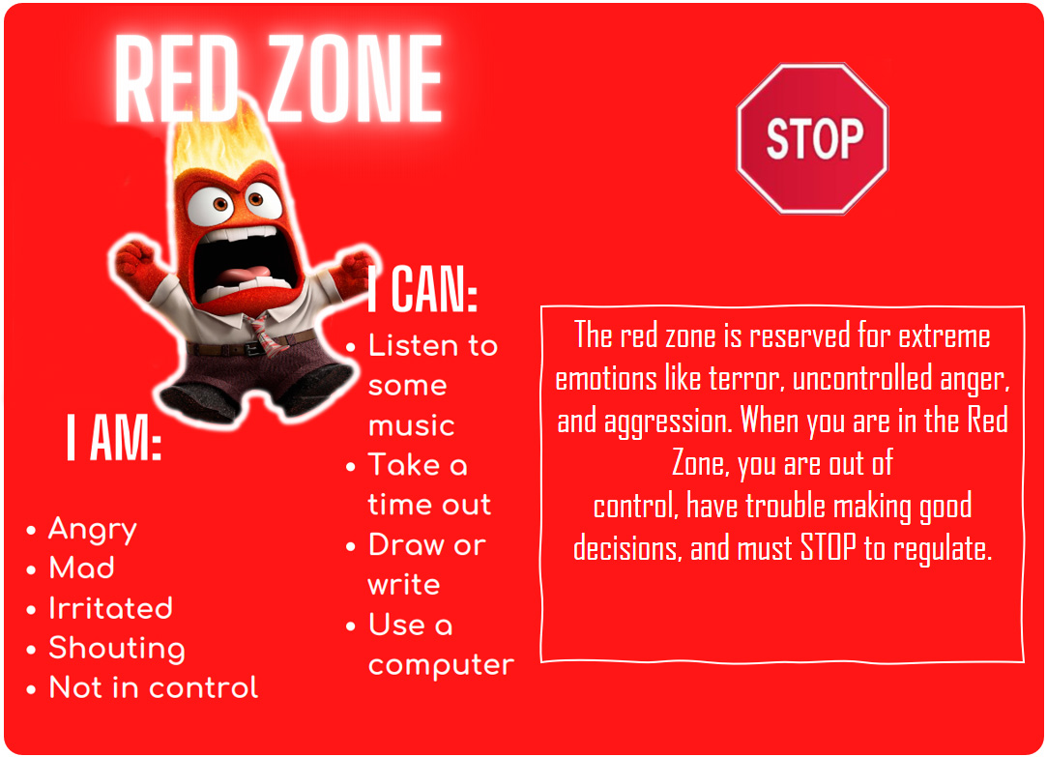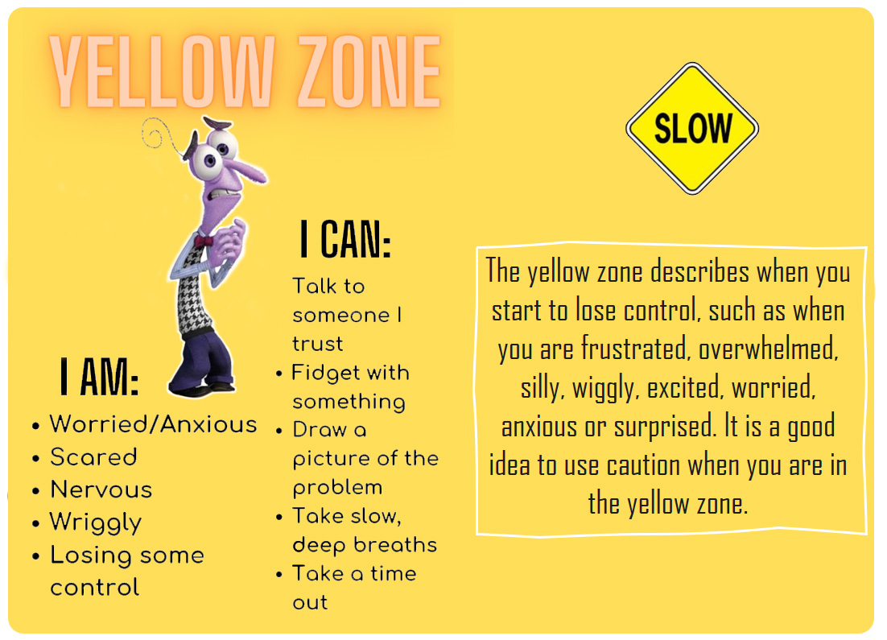
When you’re in the blue zone, your body is
running slow, such as when you are tired, sick,
sad or bored.

The yellow zone is when you start to lose control, such as when you are frustrated, overwhelmed, silly, excited, worried, or surprised. It is a good idea to use caution when you are in the yellow zone.

The Green Zone, like a green light, is when you are “good to go.” If you are in the Green Zone, you may feel happy, calm, and focused.

The red zone is reserved for extreme emotions like terror, uncontrolled anger, and aggression. When you are in the Red Zone, you are out of
control, have trouble making good decisions, and must STOP.

ZONES OF REGULATION

